THE NEOTIA UNIVERSITY
Department of Computer Science & Engineering (AI & ML)
PROJECT DEVELOPMENT DOCUMENT
Loan Verification System
Submitted in partial fulfilment of the requirements for the degree of
Bachelor of Technology (B.Tech) — Computer Science & Engineering (AI & ML)
Submitted by
Krandashi Maity
UID: TNUR20242053100101
Section: B
Course: AI & ML, B.Tech, CSE
Internship Details
Internship Company: Kognitive
Guide/Trainer: Bikash Bej
Duration: 15th June – 15th July

PROJECT DEVELOPMENT DOCUMENT
Loan Verification System — Document Verification Portal
Login-Gated Document Upload with Interactive Visual Analytics
Prepared by: krandashi Maity

1. Abstract
Loan Verification System is a two-page web application that authenticates a user through a username/password login screen, then lets them select a document type — Salary Slip or Bank Statement — and upload the corresponding file. After a short verification step, the application renders a visual breakdown of the document's contents: a pie chart of salary components (Basic Pay, HRA, Deductions, Net Pay) for a Salary Slip, and a pie chart plus a bar chart of category-wise expenses (Food, Transport, Recharge, Shopping, Bills) for a Bank Statement.
The project was deliberately built without a document-parsing (OCR) pipeline or a trained machine learning model at this stage: the verification step and the chart data currently use fixed, representative sample values. This keeps the system simple, dependency-free, and fast to deploy while the login flow, upload flow, and visualization layer are finalized. The delivered implementation is a self-contained HTML/CSS/JavaScript application using Chart.js for rendering, which runs entirely client-side in a browser with no installation required. A parallel Python/Streamlit version was also produced, structured so a real parsing step can be added on the server side later.

2. Introduction

2.1 Background
Reviewing a salary slip or a bank statement and mentally breaking down where money comes from or goes is a routine task most people do by eye — flipping between numbers on a payslip, or scanning a transaction list to see which categories dominate spending. Doing this manually is slow, and most personal finance documents are handed over as flat images or PDFs with no built-in visualization.

2.2 Problem Statement
There is a need for a simple, self-contained portal where a user can log in, upload one of two common financial document types, and immediately see a clear visual breakdown of that document's key figures — without requiring a full banking-grade verification system or a complex setup process.

2.3 Objectives
- To build a simple, secure-feeling login page with clear, color-coded success/failure feedback.
- To build a document upload page with a document-type dropdown (Salary Slip / Bank Statement) and a file selector.
- To render a pie chart of salary components immediately after a Salary Slip is uploaded and verified.
- To render a pie chart and a bar chart of category-wise expenses immediately after a Bank Statement is uploaded and verified.
- To keep the design clean, minimal, and easy to extend with real document-parsing logic in a later phase.

2.4 Scope
The current phase covers user authentication (single, personalized credential pair), document-type selection, file upload with basic validation, a simulated verification step, and chart-based visualization of representative data for both document types. It does not yet include real OCR/text extraction from the uploaded file, a persistent database, or multi-user accounts — these are documented under Future Work (Section 7.4).

3. Methodology
The project was built and iterated feature-by-feature, with each capability manually verified before the next was layered on top. The actual build sequence was:
- Requirement identification — decided the two supported document types, the fields needed for each chart, and the required login flow.
- Login page build — username/password fields, a credential match check, and color-coded (green/red) success/failure messaging.
- Upload page build — a document-type dropdown, a file selector, an "Upload & Verify" button, and a verification status indicator.
- Chart integration — selected Chart.js, defined the data shape for each document type, and wired the dropdown selection to the correct chart set.
- Visual design pass — applied a consistent clean, paper-style aesthetic with a verification "stamp" motif and deliberate typography.
- Personalization — replaced placeholder demo credentials with the real required username/password, and removed the on-screen credentials hint for privacy.
- Manual end-to-end testing — checked the login success and failure paths, dropdown switching between document types, the empty-file upload warning, and correct chart rendering for each document type, confirmed against the running application (see Section 5).

4. Technical Components

4.1 System Architecture Overview
The application follows a minimal, client-only structure: a single HTML/CSS/JavaScript file handles the login UI, the upload UI, and pie/bar chart rendering entirely in-browser. There is no separate backend API, database, or external inference service in the current phase.
Layer | Technology (actual) | Purpose
Frontend | HTML5, CSS3, vanilla JavaScript | Login UI, upload UI, view switching
Charting | Chart.js (UMD build, CDN-hosted) | Pie and bar chart rendering in the browser
Typography / Design | Google Fonts (Newsreader, IBM Plex Sans, IBM Plex Mono) | Clean, paper-style visual design
State management | In-memory JavaScript variables | Tracks logged-in status, selected document type, and verification status
Data source | Fixed representative sample values | Powers the Salary Slip and Bank Statement charts until real parsing is added

4.2 Libraries and Tools Used
Category | Library / Tool | Use in Project
Charting | Chart.js 4.4.0 (CDN) | Pie and bar chart rendering
Typography | Google Fonts (Newsreader, IBM Plex Sans, IBM Plex Mono) | Visual design and readability
Markup / styling | HTML5, CSS3 (custom properties / CSS variables) | Page structure and the paper-style theme
Optional Python variant | Streamlit, pandas, Plotly Express | Equivalent flow, runnable as a Python server app

4.3 Data Schema
The application does not use a persistent database in the current phase. Instead of database tables, its "schema" is the in-memory state held for the duration of a browser session:
Field | Scope | Description
logged_in (view state) | Session | True once the entered credentials match the stored username/password
doc_type | Session | Currently selected document type ("Salary Slip" or "Bank Statement"); determines which chart set renders
verified | Session | True once the "Upload & Verify" step has completed for the current document

4.4 Model Training
No machine learning model is trained or used in this project. This was a deliberate scoping decision rather than an oversight, and is documented here because it shapes the current architecture.

4.4.1 What a full version would require
Populating the charts with numbers taken directly from an uploaded Salary Slip or Bank Statement would require a document-parsing step — for example OCR for scanned images, or text/table extraction for PDFs — plus layout-specific logic or a trained model to reliably locate the right fields across different document formats.

4.4.2 Why it was deferred
- Real parsing/ML adds a materially larger scope (handling multiple file formats, inconsistent layouts, and model accuracy/training data requirements) than the login-and-visualization flow being finalized first.
- A stable, well-tested UI and chart specification is a prerequisite for plugging in a parser or model later — building that first, before the target fields and chart shapes were finalized, risked rework.

4.4.3 Final approach for this phase
The "Upload & Verify" action performs a simulated verification (a brief loading state) and then renders a fixed, representative dataset for the selected document type. This allows the full login → upload → verified visualization flow to be built, tested, and refined end-to-end, and keeps the two chart specifications — Salary Slip fields, and Bank Statement categories — as stable targets for a future parser or model to populate.

4.5 Testing & Prediction

4.5.1 Manual UI testing
- Login tested with correct credentials (green "Login Successfully" message, redirect to upload page) and incorrect credentials (red "Login Failed!" message, stays on login page).
- Document-type dropdown tested to confirm switching between "Salary Slip" and "Bank Statement" renders the correct chart set.
- Upload button tested with no file selected, confirming the expected warning prompt appears.

4.5.2 End-to-end verification
The full flow was run on the live application and confirmed visually — see the screenshots in Section 5, which were captured directly from the running app rather than mockups.

4.5.3 "Prediction" (Verification) Flow
Since there is no ML inference step, the equivalent of a "prediction" in this system is: (1) the user selects a document type and a file and clicks "Upload & Verify"; (2) a brief loading indicator is shown; (3) a verified confirmation (stamp/success message) is displayed; (4) the chart(s) corresponding to the selected document type are rendered using the representative sample dataset.

5. Visualization (Project UI)
This section shows the application's actual screens, captured from the running app.

5.1 Login Page
Allows the user to log in with a username and password. Correct credentials show a green success message and move to the upload page; incorrect credentials show a red error message and keep the user on this page. Credentials are personalized and are not displayed anywhere on the page.
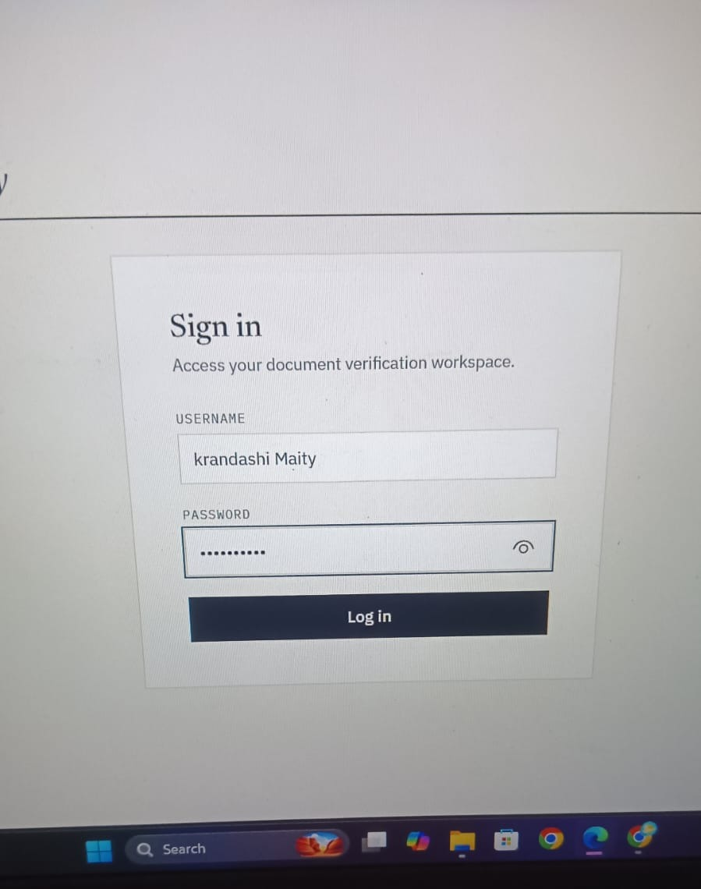
Figure 1: Login Page — live screenshot showing the username/password fields and Log in button.

5.2 Document Upload Page
Reached after a successful login. Contains a document-type dropdown, a file selector, and an "Upload & Verify" button, shown here together with the verified Salary Slip result that appears below it on the same page after upload.
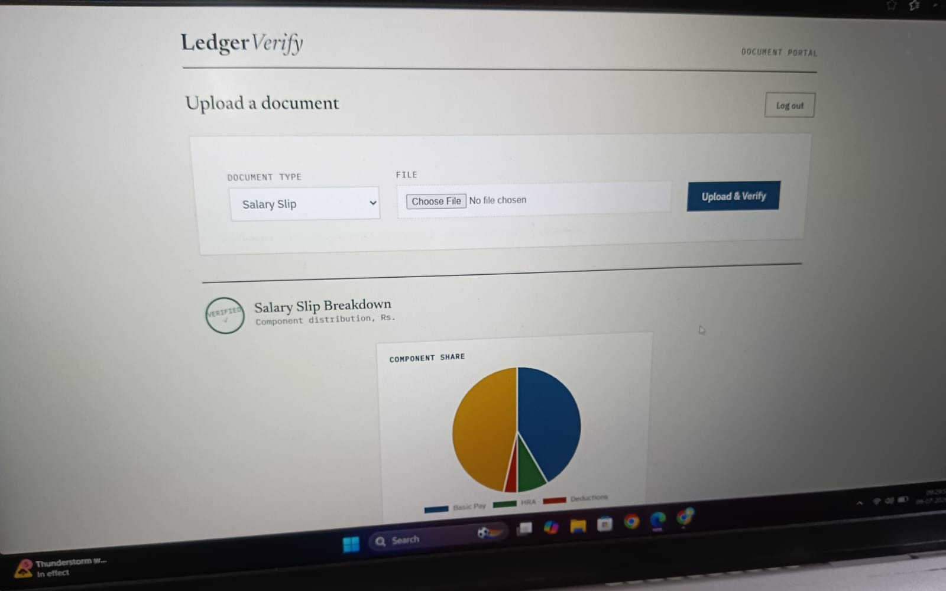
Figure 2: Document Upload Page — live screenshot showing the dropdown, file selector, Upload & Verify button, and the verified Salary Slip breakdown rendered below.

5.3 Salary Slip Review — Salary Distribution Pie Chart
A closer view of the Salary Slip result shown in Figure 2. A pie chart breaks down Basic Pay, HRA, and Deductions, alongside a data table.
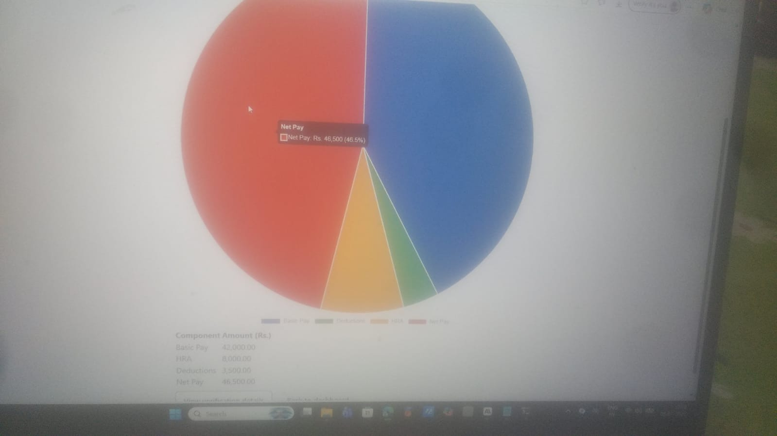
Figure 3: Salary Slip verified view — live screenshot of the salary component pie chart and breakdown table.

5.4 Bank Statement Review — Category Pie Chart & Bar Chart
Shown after a Bank Statement is uploaded and verified. A pie chart and a bar chart show spending grouped into categories (Food, Transport, Recharge, Shopping, Bills), alongside a data table.
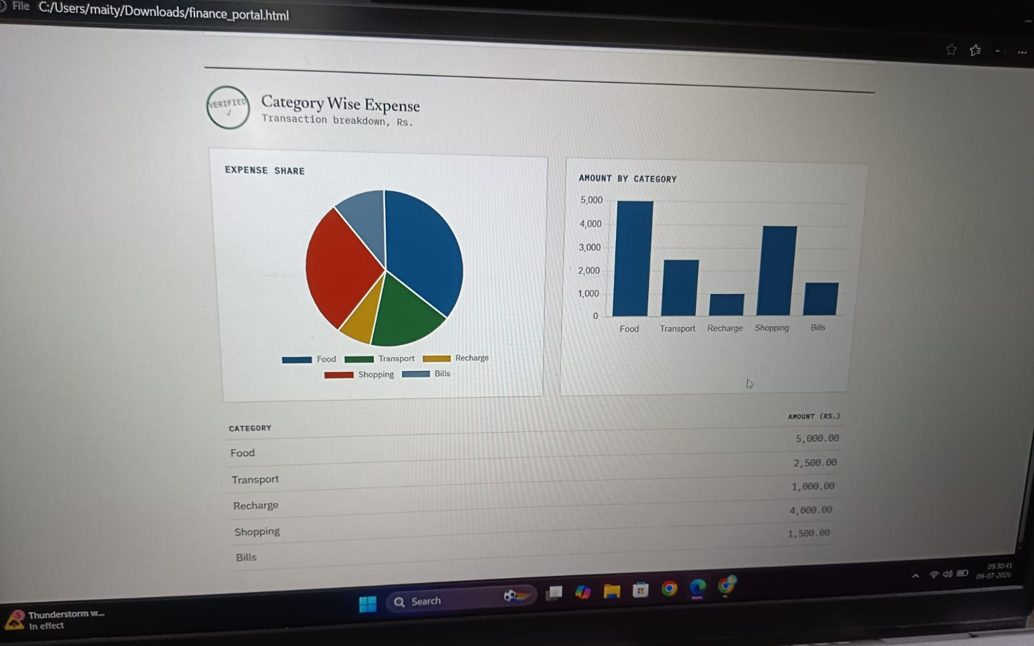
Figure 4: Bank Statement verified view — live screenshot showing both the category-wise expense pie chart and bar chart, plus the data table.

6. System Architecture

6.1 Architecture Layers
- Client Layer: browser-rendered login and upload pages (static HTML/CSS/JS), with Chart.js for in-browser chart rendering.
- State Layer: in-memory JavaScript state tracking login status, selected document type, and verification status — no data is written to disk or a database in the current phase.
- Presentation Layer: fixed representative datasets for Salary Slip and Bank Statement charts, structured to match what a future parser would output.

6.2 High-Level Data Flow
- User opens the Login Page and enters a username and password.
- Credentials are checked; a match shows a green success message and moves to the Document Upload Page, a mismatch shows a red error and keeps the user on the Login Page.
- User selects a document type from the dropdown and chooses a file to upload.
- Clicking "Upload & Verify" triggers a brief simulated verification step.
- Once verified, the chart(s) matching the selected document type are rendered using the representative sample dataset.
- The user may log out at any point, returning to the Login Page and clearing the session state.
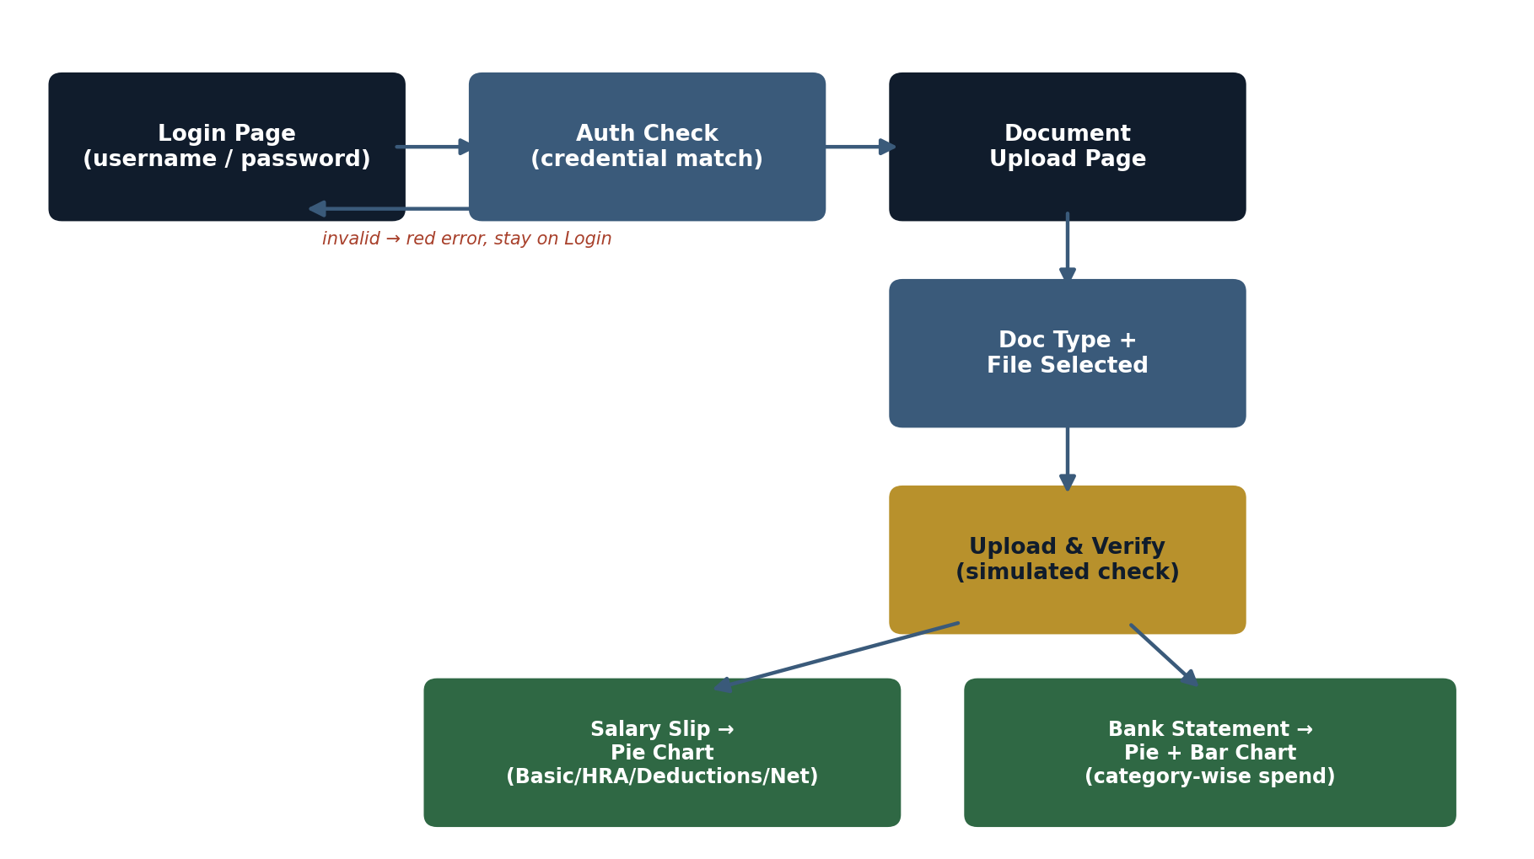
Figure 5: End-to-end application flow diagram.

7. Final Outcome (Results & Discussion)

7.1 Results
The completed system allows a user to log in, select a document type, upload a file, and receive a clear visual breakdown of representative financial data through a pie chart (Salary Slip) or a pie chart plus bar chart (Bank Statement). The full flow was run on the live application and confirmed working end-to-end, as shown by the screenshots in Section 5.

7.2 Discussion
Building the login flow, upload flow, and chart specification first — before adding real document parsing or a trained model — made it possible to finalize and test the user-facing experience quickly. This mirrors a common and reasonable engineering approach: get the interface and data contract stable first, then plug in the real data source behind it.

7.3 Limitations
- Chart data is currently representative/sample data, not extracted from the actual uploaded file.
- Login credentials are checked client-side inside the HTML/JS file, which is visible to anyone who inspects the page source — acceptable for personal/demo use only.
- No data is persisted between sessions — refreshing or closing the page clears all state.
- No machine learning model or OCR pipeline is used at this stage (see Section 4.4).

7.4 Future Work
- Add a real document-parsing step (OCR for images, text/table extraction for PDFs), optionally backed by a trained model, so charts reflect the actual uploaded document.
- Move credential checking to a secure backend with hashed password storage.
- Add persistent storage (a database) so uploads and results are saved across sessions.
- Support multiple user accounts with individual login credentials.
- Add a downloadable verification report (PDF) summarizing each upload.

